Configuring the target server settings
Before you begin creating enterprise applications, you must configure the settings for the application server and/or web server to which you are going to deploy.
Tip: Be sure to see the server-specific chapters for the various servers to find additional configuration information for each server. These are the chapters:
- "Using JBuilder with Borland servers"
- "Using JBuilder with BEA WebLogic servers"
- "Using JBuilder with IBM WebSphere servers"
- "Using JBuilder with JBoss"
- "Using JBuilder with iPlanet servers"
- "Using JBuilder with Tomcat"

Supported servers
JBuilder supports the following servers:
- Borland Enterprise Server 5.2.1
- BEA WebLogic Server 6.1 SP 5 (and all back versions of 6.1 service packs)
- BEA WebLogic Server 7.0 SP 4 (and all back versions of 7.0 service packs)
- BEA WebLogic Platform 8.1 SP 1
- IBM WebSphere Application Server 4.0.6 Single Server
- IBM WebSphere Application Server 4.0.6 Advanced Edition
- IBM WebSphere Application Server 5.0.2
- Sun iPlanet Application Server 6.5 SP 1 Update 3
- JBoss Application Server 3.0.7
- JBoss Application Server 3.2.1
- Tomcat 3.3.1
- Tomcat 4.0.6
- Tomcat 4.1.27

Setting up servers within JBuilder
This is a feature of JBuilder Developer and Enterprise
To configure the settings to target one or more application servers,
- Choose Tools|Configure Servers. The Configure Servers dialog box is displayed:
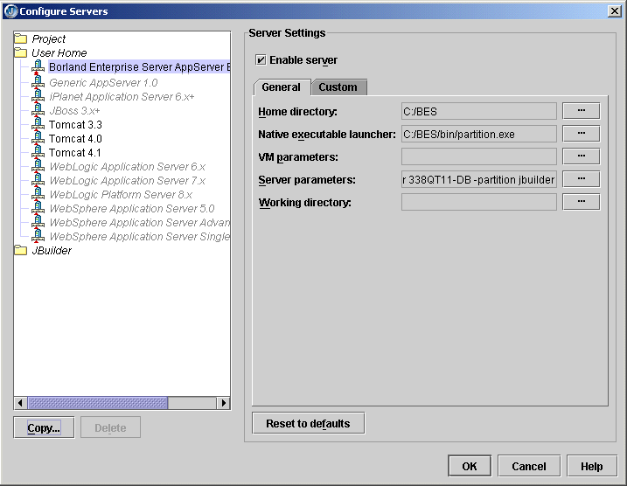
The left side of the dialog box lists the servers that can be configured in JBuilder and for which JBuilder finds a registered OpenTool.
- Select the server you want to configure by clicking it in the pane on the left.
The right side of the dialog box lists the default settings for the selected server. Each application server except Generic App Server 1.0 and all three versions of Tomcat has both a General and a Custom page for editing settings. The General page has fields that all the application servers have in common, while the Custom page has fields that are specific to the selected application server. In some cases, modifying a Custom setting will update a setting on the General page and vice versa.
The Generic AppServer 1.0 server option is a generic option. It represents a basic application server that supports EJB 1.1 and/or EJB 2.0 development. Select it if the application server you use is not currently supported by JBuilder. You will probably want to edit the resulting deployment descriptor with tools supplied with that application server to get the exact settings you want. You could also choose this option if the you aren't targeting a specific application server.
- Check the Enable Server check box at the top of the dialog box.
Checking this option enables the fields for the selected application server. You won't be able to edit any fields until it is checked. The Enable Server check box also determines whether this server will appear in the list of servers when you select a server for your project using the Server page of the Project|Project Properties dialog box.
JBuilder provides default settings for the selected server. If JBuilder's default settings are not appropriate, edit any of the settings as needed. Some servers require you to enter settings in addition to the defaults. Clicking the OK button in this dialog box when not all required values are set or selecting another server while the current one is enabled displays a message dialog box that informs you about the missing settings and usually selects the control representing the missing setting.
- If you want to change any of the settings, click the ellipsis (…) button next to the field and make your changes.
You can add any necessary application dependencies to the server's classpath by clicking the Required Libraries tab and using the Add button to add the libraries the server needs.
- Click the Custom tab to view fields unique to the server. Most application servers allow you to specify the location of the JDK the server uses; some require you to specify the JDK location for successful configuration completion. Updates you make on the Custom page can update settings on the General page. (Note that Tomcat configurations do not have a Custom tab.)
Following are the JDKs and their installed locations for the application servers supported by JBuilder:
  - Borland Enterprise Server AppServer Edition 5.2.1: <bes home>/jdk/jdk1.3.1 or <bes home>/jdk/jdk1.4.1 (the default value)
  - WebLogic Server 6.x: <bea home>/jdk131_06
  - WebLogic Server 7.x: <bea home>/jdk131_08
  - WebLogic Platform Server 8.1: <bea home>/jdk141_03. WebLogic 8.1 also supports JRockit (a JDK optimized for server applications), so the JDK directory could be <bea home>/jrockit81_141_03
  - WebSphere 4.0 (either Advanced Edition or Single Server): <websphere home>/java
  - WebSphere 5.0: <websphere home>/java
  - iPlanet 6.x: <iPlanet home>/usr/java
Once you've made your edits and click the OK button to accept your changes and close the dialog box, JBuilder runs a validation pass on the settings for the server. If you prefer that JBuilder not try to validate your changes, uncheck the Enable Server dialog box. Your changes will still be saved when you click OK, but you can then go back later to make further changes that you need before choosing to validate the settings. You must check the Enable Server check box, however, before you can select the server you are configuring for use in a project. Selecting OK saves changes for all servers you've enabled, disabled, or modified. If, while using the dialog box, you move between servers, JBuilder attempts to validate the server you are leaving.
- Click OK when you are through configuring the application server.
When you click OK and the Enable Server check box is checked, JBuilder attempts to verify your settings. If errors are detected, a message box containing information about the errors appears. If the Enable Server option is unchecked, the dialog box simply closes and no setting validation is performed.
Once a server is properly configured and validated, the server you configured is listed in black type in the pane on the left. Gray type indicates the server hasn't been configured yet. Red type indicates an error condition; specifically it means the server's library containing its settings has been read, but the OpenTool representing the server can't be found. You can delete a server shown in red by selecting it and clicking the Delete button.
The Reset To Defaults button sets the settings back to the values they originally had when JBuilder was first installed and the server is disabled.
If a dialog box appears with a message that you must restart JBuilder, you must close and then restart JBuilder for changes to become effective; otherwise, restarting JBuilder is not necessary.

Creating a duplicate configuration to edit
Once you've created a server configuration, you might find you'd like to have a similar one, but with some slight differences. Follow these steps to create a duplicate configuration you can then edit:
- Choose Tools|Configure Servers to display the Configure Servers dialog box.
- Select the server configuration you would like to duplicate from the left pane.
- Click the Copy button at the bottom of the left pane to display the Copy Server wizard:
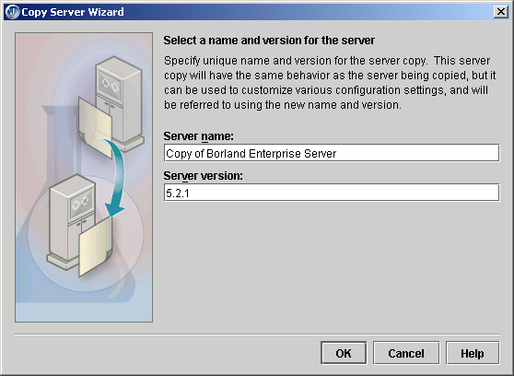
- Specify the name you want to use to identify this server configuration in the Name For This Server field.
- Specify the server version in the Version For This Server field.
- Click OK.
- Select your new configuration in the left pane of the Configure Servers dialog box and make the changes to the settings you need using the General and Custom pages.
Copying a server configuration also creates copies of that server's tools. You could, therefore, create a duplicate server configuration and modify just the server's tools as the only difference between the two configurations. As another example, you could have the copied configuration refer to a different home directory if you have slightly different versions of that server installed. You can also delete a server configuration in the Configure Servers dialog box.

Adding a service pack
If you want to add a service pack to your application server configuration, follow these steps:
- Choose Tools|Configure Servers.
- Select your server from the list of servers in the pane on the left side of the dialog box.
- Click the General tab, then the Class tab, if it isn't already selected.
- Click Add.
- Navigate to the location of the service pack JAR file.
- Click OK twice to close all dialog boxes.

The created libraries
When you configure the server settings, one or more libraries are created for you automatically in your JBuilder home directory that contain all the application server files you will need for enterprise bean development with the application server of your choice. These are the libraries created for you, listed by application server:
Borland Enterprise Server 5.2.1
Borland Enterprise Server 5.2.1 Client: All JARs needed to run a client.
Borland Enterprise Server 5.2.1 Servlet: Used for web applications.
WebLogic 8.1
WebLogic 8.1 Client: All JARs needed to run a client.
WebLogic 8.1 Deploy: JARs needed to run the WebLogic 8.1 deploy tool.
WebLogic 8.1 Servlet: Used for web applications.
WebLogic 7.x
WebLogic 7.x Client: All JARs needed to run a client.
WebLogic 7.x Deploy: JARs needed to run the WebLogic 7.x deploy tool.
WebLogic 7.x Servlet: Used for web applications.
WebLogic 6.x
WebLogic 6.x Client: All JARs needed to run a client.
WebLogic 6.x Deploy: JARs needed to run the WebLogic 6.x deploy tool.
WebLogic 6.x Servlet: Used for web applications.
WebSphere 5.0
WebSphere 5.0 Client: JARs needed to run a client.
WebSphere Application Server 5.0 Ext Dirs: JARs used during server startup.
WebSphere Application Server 5.0 EJB Deploy: JARs used to compile enterprise beans and create stubs.
WebSphere Application Server 5.0 Servlet: Used for web applications.
WebSphere 4.0 Single Server
WebSphere AES 4.0 Client: JARs needed to run a client.
WebSphere AES 4.0 Ext Dirs: JARs used during server startup.
WebSphere AES 4.0 EjbDeploy: JARs used to compile enterprise beans and create stubs.
WebSphere AES 4.0 SeAppInstaller: JARs used to run the WebSphere 4.0 deploy tool (SeAppInstaller).
WebSphere AES 4.0 Servlet: Used for web applications.
WebSphere 4.0 Advanced Edition
WebSphere AE 4.0 Client: JARs needed to run a client.
WebSphere AE 4.0 Ext Dirs: JARs used during server startup.
WebSphere AE 4.0 XmlConfig: JARs used to run the WebSphere 4.0 AE deploy tool.
WebSphere AE 4.0 EjbDeploy: JARs used to compile enterprise beans can create stubs.
WebSphere AE 4.0 Servlet: Used for web applications.
JBoss 3.x+
JBoss 3.x+ Client: JARs needed to run a client.
JBoss 3.x+ Servlet: Used for web applications.
iPlanet 6.x
iPlanet 6.x Client: JARs needed to run a client.
iPlanet 6.x Servlet: Used for web applications.
Tomcat
Tomcat 3.3 Servlet: Used for web applications.
Tomcat 4.0 Servlet: Used for web applications.
Tomcat 4.1 Servlet: Used for web applications.

Selecting a server
JBuilder can target multiple servers. You can choose a single application server for all stages of EJB and web application development, or you can choose different servers for different aspects of development. For example, you can select one server to use to develop enterprise beans and another to develop web applications.
To select one or more servers to use for your project,
- Choose Project|Project Properties.
- Select Server in the dialog box tree. The Server page is displayed:
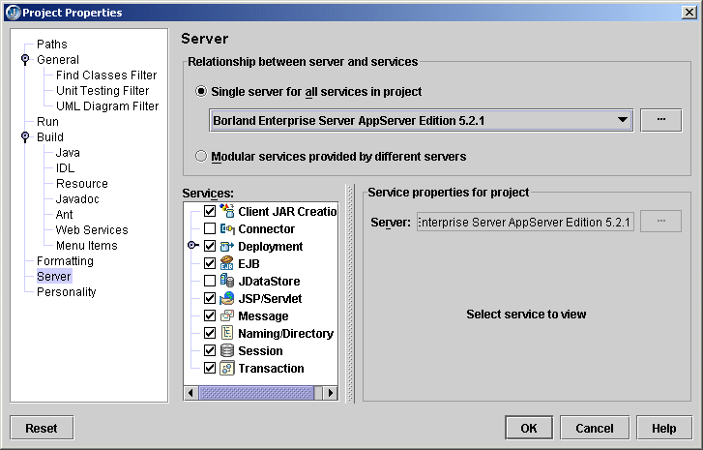
- Decide whether you want to use a single server for all aspects of development or different servers to handle different areas of development.
  - To use a single server,
    - Select the Single Server For All Services In Project option and select the server from the drop-down list.
    - If you want to make changes to the configuration settings for the server, click the ellipsis (…) button and edit the settings you want on the General and Custom pages. Click OK.
You can also use this dialog box to select a different server.
    - If you don't want a particular service started when the server starts up, uncheck the check box next to the service in the Services list. This feature currently applies only to the Borland Enterprise Server as it is the only one which allows you to start and stop selected services.
If you uncheck the Deployment or Client JAR Creation services, the corresponding menu items will be disabled on the JBuilder Tools menu. If you uncheck the JSP/Servlet service, web server support is disabled. If you uncheck the Naming/Directory service for Tomcat, naming service support is disabled.
  - To use different servers for different services,
    - Select the Modular Services Provided By Different Servers option.
    - Check the check boxes next to all the services for which you want to specify an application server in the Services list.
    - Click one of the checked services to select it in the Services list.
    - In the Service Properties For Project group box, use the Server drop-down list to select the server you want to use for this service.
If server-specific properties are available for the server you selected for the particular service you are working with, they will appear below the Server drop-down list. If the Deployment service is selected, a Build Target For Deploying To Server drop-down list appears on the Service Properties For Project panel. Select the type of build you want to occur. If the EJB service is selected, you'll see read-only information appear that is intended to help you decide which server is appropriate for your needs.
For Borland Enterprise Server: The Deploy jndi-definitions.xml option determines whether the jndi-definitions.xml file is included in any of the deployment actions you select. Uncheck it if you don't want it included. jndi-definitions.xml is an XML deployment descriptor for EJB 2.0 resources.
For WebLogic 6.x - 8.1: If you select the JSP/Servlet service, the service properties include a Map Project Apps At Runtime option. When this option is selected (the default value) all web applications in the project deploy from the web application directory and not as a WAR when the server starts up.
For WebLogic 7.x - 8.1: If you select the EJB service, the service properties include a combo box with options to deploy (auto-deploy) data sources for all EJB modules in the project. These are the options:
      - Map Project Data Sources: Maps data sources for all EJB modules in config.xml for the domain specified in the server configuration. DataSource entries are removed when the server shuts down.
      - Map And Persist Project Data Sources: Maps data sources for all EJB modules in config.xml for the domain specified in the server configuration. Data Source information is persisted in config.xml. DataSource entries are removed when the server shuts down.
      - Do Not Map Project Data Sources: Does not map any data sources.
Note that JBuilder also adds the JDBC driver (if it can be located in the project's required libraries) to the server's classpath at start up time. All data sources created by JBuilder are transactional data sources.
    - If you want to make changes to the configuration settings for the server selected for the service, click the ellipsis (…) button and edit the settings you want on the General and Custom pages. Click OK.
    - Repeat these steps for each service you want access to.
- Click OK.
If you neglect to select one ore more servers for a project, the Server page of the Project Properties dialog box appears when you start an EJB wizard from the object gallery. All EJB projects must have one or more selected servers.

Setting up JDBC drivers
To enable JBuilder's EJB wizards and EJB Designer to access a database, you must install the JDBC driver supplied by the database vendor and set up the driver in JBuilder. Install a JDBC driver following the vendor's instructions.
To begin setting up the driver in JBuilder, select Tools|Enterprise Setup to display the Enterprise Setup dialog box. Select Database Drivers in the tree to display the Database Drivers page. Use this page to add a new database driver to JBuilder. See the following section for step-by-step instructions.

Creating the .library and .config files
There are three steps to adding a database driver to JBuilder:
- Creating a library file which contains the driver's classes, typically a JAR file, and any other auxiliary files such as documentation and source.
- Deriving a .config file from the library file which JBuilder adds to its classpath at start-up.
- Adding the new library to your project, or to the Default project if you want it available for all new projects.
The first two steps can be accomplished from the Database Drivers page:
- Open JBuilder and choose Tools|Enterprise Setup. Click the Database Drivers tab which displays .config files for all the currently known database drivers.
- Click Add to add a new driver, then New to create a new library file for the driver. The library file is used to add the driver to the required libraries list for projects.
Note: You can also create a new library under Tools|Configure Libraries, but since you would then have to use Enterprise Setup to derive the .config file, it is simpler to do it all here.
- Type a name and select a location for the new file in the Create New Library dialog box.
- Click Add, and browse to the location of the driver. You can select the directory containing the driver and all it's support files, or you can select just the archive file for the driver. Either will work. JBuilder will extract the information it needs.
- Click OK to close the file browser. This displays the new library at the bottom of the library list and selects it.
- Click OK. JBuilder creates a new .library file in the JBuilder /lib directory with the name you specified (for example, InterClient.library). It also returns you to the Database Drivers page which displays the name of the corresponding .config file in the list which will be derived from the library file (for example, InterClient.config).
- Select the new .config file in the database driver list and click OK. This places the .config file in the JBuilder /lib/ext directory.
- Close and restart JBuilder so the changes to the database drivers will take effect, and the new driver will be put on the JBuilder classpath.
Important: If you make changes to the .library file after the .config file has been derived, you must re-generate the .config file using Enterprise Setup, then restart JBuilder.
Now that JBuilder can see the database driver, you must add the database driver library to the Required Libraries list in Project|Properties, or Project|Default Properties.

Adding the JDBC driver to projects
Projects run from within JBuilder use only the classpath defined for that project. Therefore, to make sure the JDBC driver is available for all new projects that will need it, define the library and add it to your default list of required libraries. This is done from within JBuilder using the following steps:
- Start JBuilder and close any open projects.
- Choose Project|Default Project Properties.
- Select the Required Libraries tab on the Paths page, then click the Add button.
- Select the new JDBC driver from the library list and click OK.
- Click OK to close the Default Project Properties dialog box.
Note: You can also add the JDBC driver to an existing project. Just open the project, then choose Project|Properties and use the same process as above.

Updating projects with the latest server settings
If a server configuration has been modified since a project was last opened, JBuilder updates it with the latest server settings for the project's selected server(s). So, for example, if you have modified server settings for one project and you have others that aren't open that use the same server configuration, the next time you open those other projects, your modified server settings will be in force automatically. If you want to use a similar but unique server configuration for a particular project, create a duplicate configuration using the Copy button, and use the Copy Servers wizard to edit it to your needs.
Be aware that this automatic updating of projects with the latest server settings can occur only with server configurations modified in JBuilder 9 or X. If you attempt to transfer server libraries from a previous JBuilder version, your projects won't be updated with them. You can still tell JBuilder to update the project manually:
- Right-click the project node of the project you want to update in the project pane and choose Properties.
- Select the Servers page.
- Click the ellipsis (…) button next to your selected single server or the separate service servers and make your changes.
- Click OK to close the dialog box.

Updating from an earlier version of JBuilder
Previous versions of JBuilder supported an older module format. Your old modules will be automatically converted to the new module format in JBuilder X. Once the conversion has taken place, you will not be able to share modules between JBuilder X and an earlier version of JBuilder.

